# **Final Year Project: Multiplayer Online Game with AI - Progress Report**

## **Progress Chart**

|  |  |  |  |  |  |  |  |  |  |  |  |  |  |
| --- | --- | --- | --- | --- | --- | --- | --- | --- | --- | --- | --- | --- | --- |
| **Agenda\Week** | **1** | **2** | **3** | **4** | **5** | **6** | **7** | **8** | **9** | **10** | **11** | **12** | **13** |
| Determine project direction |  |  |  |  |  |  |  |  |  |  |  |  |  |
| Find out feasibility of Mahjong AI |  |  |  |  |  |  |  |  |  |  |  |  |  |
| Explore Unity |  |  |  |  |  |  |  |  |  |  |  |  |  |
| Study Machine Learning |  |  |  |  |  |  |  |  |  |  |  |  |  |
| Research on TensorFlow & Pytorch |  |  |  |  |  |  |  |  |  |  |  |  |  |
| Research and understand Machine Learning agents (ML-agents) in Unity |  |  |  |  |  |  |  |  |  |  |  |  |  |
| Try out demo game using ML-agent in Unity |  |  |  |  |  |  |  |  |  |  |  |  |  |
| TicTaeToe AI Game Development |  |  |  |  |  |  |  |  |  |  |  |  |  |
| Research on Multiplayer Game Development |  |  |  |  |  |  |  |  |  |  |  |  |  |

## **Tasks Completed**

|  |  |  |
| --- | --- | --- |
| **Date** | **Number of hours** | **Task Completed** |
| 12-AUG-20 | 1 | Determine project direction:  Discuss and decide game direction |
| 12-AUG-20 | 1 | Determine project direction:  Plan project stages |
| 17-AUG-20 | 1.5 | Find out feasibility of Mahjong AI:  Understand Mahjong logic and available Mahjong AI on market |
| 17-AUG-20 | 1 | Find out feasibility of Mahjong AI:  Research and understand Suphx development (Microsoft’s Mahjong AI) |
| 19-AUG-20 | 0.5 | Explore Unity:  Download Unity |
| 19-AUG-20 | 1.5 | Study Machine Learning:  Understand core Machine Learning concepts |
| 19-AUG-20 | 1 | Study Machine Learning:  Research on Machine Learning framework: TensorFlow vs Pytorch |
| 24-AUG-20 | 1 | Explore Unity:  Research and understand Machine Learning agents (ML-agents) in Unity |
| 24-AUG-20 | 2 | Explore Unity:  Try out demo game using ML-agent in Unity |

|  |  |  |
| --- | --- | --- |
| 31-AUG-20 | 3.5 | Tic Tac Toe AI Game Development:  Developed a 2 player Tic Tac Toe game on Unity3D.    Features:   * 2 player game * Take turns to make their next move * Able to tell apart a draw or a win      * Option to restart and play again after a draw or win is concluded |
| 2-SEP-20 | 2 | Tic Tac Toe AI Game Development:  Researched on how to implement ML-agent on a game (that is not from the demo list). Currently still trying to figure out how to use ML-agent. |
| 8-SEP-20 | 3 | Tic Tac Toe AI Game Development:  Researched on how to implement ML-agent on a game (that is not from the demo list). Most are MiniMax, trying to explore other options |
| 14-SEP-20 | 4 | Research on Development of iOS & Android Game via Unity3D  Research on Multiplayer System Architecture |
| 16-SEP-20 | 3 | Research on Unity’s multiplayer networking architecture  Research on Mirror and Photon functionalities |
| 16-SEP-20 | 3 | Unity3D 2020 file were corrupted, figuring out how to run 2 versions of Unity at the same time (2019 and 2020). Troubleshooting  Research on Mirror and Photon Demos |
| 21-SEP-20 | 4 | Space Shooter Multiplayer game with Unity3D, using Mirror (Multiplayer |
| 23-SEP-20 | 1 | Space Shooter Multiplayer game with Unity3D, using Mirror (Multiplayer |
| 24-SEP-20 | 1 | Searching for good multiplayer demo game using Photon plugin to learn from and learn the photon framework |

## **Upcoming Tasks**

1. Try out Photon Master server
2. Explore dedicated game server vs client(also the host) server – peer2peer?

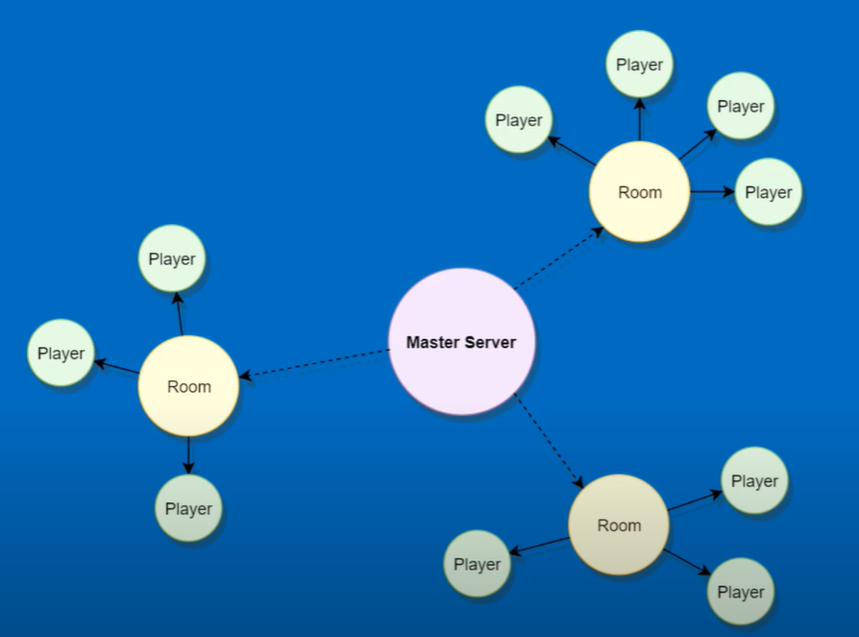  
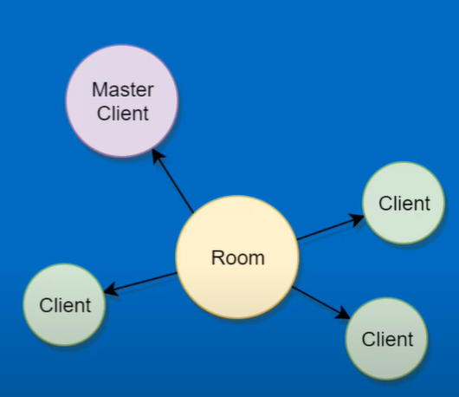

1. Explore and compare advantages and disadvantages of Mirror vs Photon
2. Try out turn based multiplayer game or find more example games to learn how they structure game code properly and the methods used
3. Plan out development of application in stages (Research > Identify > Develop > Test > Deploy)
4. Develop stage: UI Prototypes – App Development – Database Development - Asset Improvements